

DVTK Design Specification
Warehouse, Utility and Logging Libraries

1.0
2005-06-29

Table of Contents
1 Introduction 6
1.1 Purpose 6
1.2 Scope 6
1.3 Audience 6
1.4 Abbreviations and acronyms 6
1.5 References 6
1.6 History 6
2 Data-warehouse Concepts 7
3 Detail Design of Warehouse component 8
3.1 Base Warehouse item data 8
3.1.1 Setting/Getting the warehouse item data type 8
3.1.2 Updating the warehouse item data 8
3.1.3 Setting/Getting the logger 8
3.2 Warehouse Item Class 8
3.2.1 Getting the warehouse identifier 9
3.2.2 Getting the warehouse item data type 9
3.2.3 Setting/Getting the logger 9
3.2.4 Getting the warehouse item data 9
3.3 Warehouse Mapping Class 9
3.3.1 Getting the attribute mapping name 9
3.3.2 Getting the attribute mapping value 9
3.3.3 Checking the mapping 9
3.3.4 Logging the attribute name/value mapping 10
3.4 Object Warehouse Class 10
3.4.1 Setting/Getting the reference tag 11
3.4.2 Managing the stored objects by using semaphore 11
3.4.3 Emptying the warehouse form all stored objects 11
3.4.4 Searching the warehouse for the identified object 11
3.4.5 Storing the object data in the warehouse 11
3.4.6 Removing the object data from the warehouse 11
3.4.7 Updating the object data in the warehouse 11
3.4.8 Retrieving the object data from the warehouse 11
3.4.9 Registering the transfer syntaxes, appl context names and verification SOP class for the use of scripting component 11
3.4.10 Managing the Name / Value mapping to the mapping list 11
3.4.11 Setting the labeled value 12
3.4.12 Mapping of DIMSE commands to a WID Type 12
3.4.13 Getting the mapped name 12
3.4.14 Serialize the contents of warehouse to the UI 12
3.4.15 Log the mapping and contents of warehouse 12
4 Detail Design of Utility component 13
4.1 Base file class 13
4.1.1 Return the filename 13
4.1.2 Return the filename 13
4.1.3 Check for full pathname 13
4.1.4 Set flag for parsing file only 14
4.1.5 Setting/Getting the number of errors/warnings 14
4.1.6 Open the file 14
4.1.7 Execute the file 14
4.1.8 Save the file 14
4.1.9 Close the file 14
4.2 Endian class 15
4.2.1 Set endianess 15
4.2.2 Get endianess 15
4.2.3 Read binary data 15
4.2.4 Write binary data 15
4.2.5 >> operator 16
4.2.6 << operator 16
4.3 Data transfer class 17
4.3.1 Pure virtual functions 17
4.3.2 Checking for little endianess of current data transfer 18
4.3.3 Determine if VR is explicit 18
4.3.4 Determine if data is compressed 18
4.3.5 Getting/Setting the storage mode 18
4.3.6 Getting/Setting the transfer syntax code 18
4.3.7 Getting the transfer syntax 18
4.3.8 Mapping of the VR into a UINT presentation 18
4.3.9 Mapping of the VR into a enumerated VR value presentation 18
4.4 File transfer class 19
4.4.1 Initializing the data decode 20
4.4.2 Terminating the data decode 20
4.4.3 Initializing the data encode 20
4.4.4 Terminating the data encode 20
4.4.5 Rewinding the file offset by the given length 20
4.4.6 Getting/setting the current file offset 20
4.4.7 Checking for the remaining data 20
4.4.8 Opening the file for data transfer 20
4.4.9 Closing the file after data transfer 20
4.4.10 Getting the current file length 20
4.4.11 Computing the remaining data length 20
4.4.12 Writing the given data to the file 21
4.4.13 Reading the data from the file 21
4.4.14 Adding/getting the item offsets 21
4.4.15 Setting/Getting the logger 21
4.5 Helper functions 21
4.5.1 Memory functions 21
4.5.1.1 Copying the byte 21
4.5.1.2 Comparing the byte 21
4.5.1.3 Clearing the byte content in a buffer 21
4.5.1.4 Filling the byte content in a buffer 22
4.5.1.5 Filling the byte pattern in a buffer 22
4.5.1.6 Getting the size of a buffer 22
4.5.2 Index handling functions 22
4.5.2.1 Resetting the counter 22
4.5.2.2 Getting the odd number 22
4.5.3 DVT output file handling functions 22
4.5.3.1 Returning the next Storage File Extension index 22
4.5.3.2 Returning the next pixel index 23
4.5.3.3 Returning the next result file index 23
4.5.3.4 Getting the Storage File name 23
4.5.4 DICOM specific helper functions 23
4.5.4.1 Mapping the command name 23
4.5.4.2 Mapping the attribute type 23
4.5.4.3 Mapping the value type 23
4.5.4.4 Mapping the command ID 24
4.5.4.5 Mapping the command field 24
4.5.4.6 Checking the validity of UID 24
4.5.4.7 Creating the UID 24
4.5.5 Date and time functions 24
4.5.5.1 Getting the current year and day 24
4.5.5.2 Getting the current month and day 24
4.5.5.3 Getting the current date 24
4.5.5.4 Getting the real date 25
4.5.5.5 Getting the current time 25
4.5.5.6 Getting the real time 25
4.5.5.7 Getting the time as defined in system 25
4.5.6 String functions 25
4.5.6.1 Comparing the strings 25
4.5.6.2 Stripping the leading/trailing spaces in a string 25
4.5.6.3 Decoding the escape sequence 26
4.5.6.4 Converting the hex 26
4.5.6.5 Getting the epsilon 26
4.5.7 Filename functions 26
4.5.7.1 Checking for the path in the filename 26
4.5.7.2 Checking for the absolute path 26
4.5.7.3 Checking for the relative path 26
4.5.7.4 Reducing the pathname 26
4.5.7.5 Stripping the pathname 26
4.5.7.6 Correcting the pathname for a particular OS 27
4.5.7.7 Getting the current working directory 27
4.5.7.8 Creating the directory 27
4.5.7.9 Checking for the file extension 27
5 Detail Design of logging component 28
5.1 Log Class 28
5.1.1 Setting/Getting the log mask 28
5.1.2 Logging the text 28
5.1.3 Setting the log level 29
5.1.4 Setting/Getting the activity reporter 29
5.1.5 Setting/Getting the serializer 29
5.1.6 Setting/Getting the storage root directory 29
5.1.7 Setting/Getting the result root directory 29
5.1.8 Displaying the text in the UI 29
5.2 Log Message Class 29
5.2.1 Adding the message to the message list 30
5.2.2 Getting the number of messages from the message list 30
5.2.3 Getting the message ID by index 30
5.2.4 Getting the message index 30
5.2.5 Getting the message by index 30
5.3 Base Confirmer Class 30
5.3.1 Confirming the interaction 30
5.4 Base Activity Reporter Class 30
5.4.1 Reporting the activities to UI based on report level 31
5.5 Base Serializer Class 31
5.5.1 Specific serialization methods for ACSE & DIMSE objects 31
5.5.2 Specific serialization methods for old style CREATE, SET, DELETE DicomScript commands 32

Introduction

Purpose
This document describes the global and detail design of the Warehouse, Utility and Logging components. This is a living document and changes in the design should be laid down in this document. Especially the sections on detailed design of Warehouse, Utility and Logging classes may change during the project.

Scope
This document describes design of Warehouse, Utility and Logging components.

Audience
This document is intended for all the implementers in the DVT project. The reader is assumed to have basic DICOM knowledge.

Abbreviations and acronyms
Abbreviation / acronym | Description
ACSE | Association Control Service Element
Definition File | File containing the DICOM SOP Class description(s).
DIMSE | DICOM Message Service Element
DVT | DICOM Validation Tool.
Session File | File containing the test session parameters.
User | Person who is implementing the Definition library.
WID | Warehouse Item Data
VR | Value Representation

References
Reference | Title | Author/Publisher | Document number
SESSION | Test Session File Specification | R. Busbridge | XZS 980-000119.00
SCRIPT | DICOMScript Language Specification | R. Busbridge | XZS 980-000118.00
DESIGNSPEC |  | R. Busbridge  M. van Minderhout | XZS 980-000183.01
PATTERNS | Design Patterns | E. Gamma et al. | ISBN 0201633612
DCM | DICOM standard 2004 | NEMA | PS 3.0-2004

History
Version | Date | Author | Description
0.1 | 07 June 2005 | Piyush Bhageriya  Manisha Singla | Initial version
1.0 | 29 June 2005 | Piyush Bhageriya  Manisha Singla | Update for OpenSource release

Data-warehouse Concepts
The data-warehouse allows DICOMObjects to be shared between Test Sessions. DVT includes a data-warehouse in which the User stores ACSE Requests & Responses, DICOM Commands, Dataset and Item objects (DICOMObjects) for re-use in the same or other DICOMScript. The warehouse is used only through DICOMscripts.
This feature is particularly useful when performing a full system validation where more than one DICOM connection by be used (Example: A Modality can make use of the Basic Modality Worklist SOP Class, Storage SOP Class and Performed Procedure SOP Class. These can be handled within separate Test Sessions with the exchanged DICOMObjects being shared between sessions.).

Data-warehouse can be manipulated using following DICOMScript commands described below: -
- CREATE: The data-warehouse can be filled by creating ACSEObjects and DICOMObjects within the DICOMScript using the CREATE command in DICOM scripts. It is also possible to create Media Storage objects in the data-warehouse.
- SET: Once an ACSEObject or DICOMObject has been created in the data-warehouse, the paramater/attribute values can be defined using the SET command. Any number of SET commands can be applied to an ACSEObject or DICOMObject. The actual attribute values used will depend on the values given at the time the ACSEObject or DICOMObject is used.
- DELETE: An ACSEObject or DICOMObject can be removed from the data-warehouse using the DELETE command.
- COMPARE: The COMPARE command compares two attributes identified by their tag values. These tags may be different attributes in the same DICOMObject or in different DICOMObjects.
- RESET: The RESET command can be used to reset the content of the Data Warehouse (remove all entries).

Detail Design of Warehouse component

Base Warehouse item data
The Base warehouse item data class is an abstract class and manages all the scripting objects in warehouse. This class uses a Warehouse Item Data (WID) type enumeration, which identifies the type of scripting object stored in warehouse.

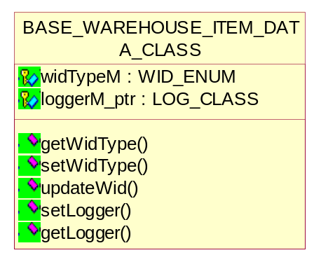
Figure 1 Class diagram of Base Warehouse item data

Setting/Getting the warehouse item data type
inline WID_ENUM getWidType();
void setWidType(WID_ENUM type);

Updating the warehouse item data
virtual bool updateWid(BASE_WAREHOUSE_ITEM_DATA_CLASS*) = 0;

Setting/Getting the logger
virtual void setLogger(LOG_CLASS *logger_ptr);
LOG_CLASS* getLogger();

Warehouse Item Class
The Warehouse item class describes individual warehouse items. This class describes the scripting object by identifier and type.

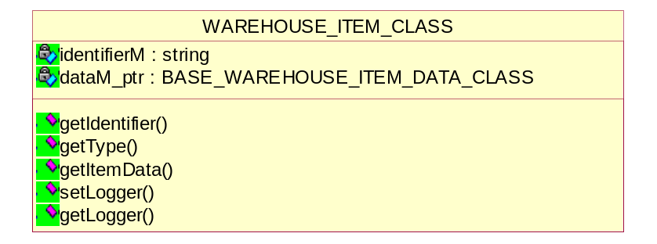
Figure 2 Class diagram of Warehouse item

Getting the warehouse identifier
string getIdentifier();

Getting the warehouse item data type
WID_ENUM getType();

Setting/Getting the logger
void setLogger(LOG_CLASS *logger_ptr);
LOG_CLASS *getLogger();

Getting the warehouse item data
BASE_WAREHOUSE_ITEM_DATA_CLASS *getItemData();

Warehouse Mapping Class
This class defines the attribute name and value mapping.

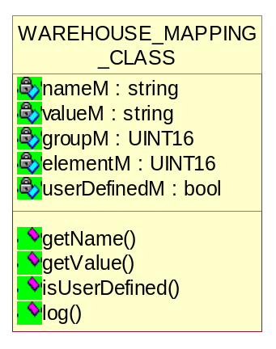
Figure 3 Class diagram of Warehouse Mapping

Getting the attribute mapping name
char *getName();

Getting the attribute mapping value
char *getValue();

Checking the mapping
bool isUserDefined();

Logging the attribute name/value mapping
void log(LOG_CLASS*);

Object Warehouse Class
This class is used to store the scripting objects in the warehouse. This class is based on the singleton pattern [PATTERNS]. The singleton pattern ensures the definition class only has one instance and provides a global point of access to it.
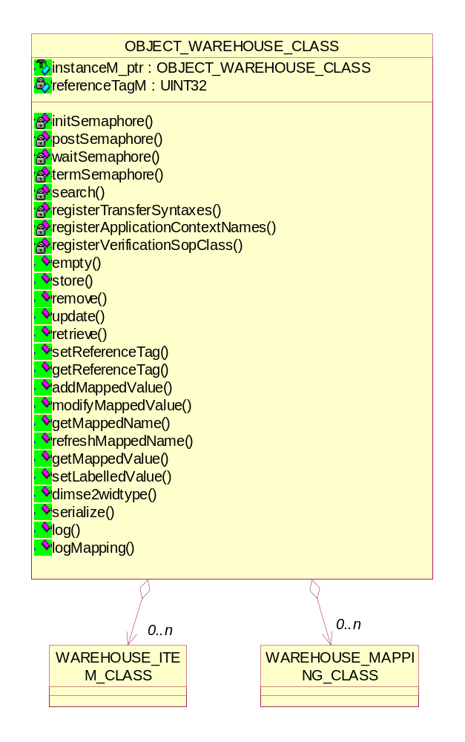
Figure 4 Class diagram of Object Warehouse

Setting/Getting the reference tag
void setReferenceTag(UINT32 tag);
UINT32 getReferenceTag();

Managing the stored objects by using semaphore
void initSemaphore();
void postSemaphore();
void waitSemaphore();
void termSemaphore();

Emptying the warehouse form all stored objects
void empty();

Searching the warehouse for the identified object
bool search(string, WID_ENUM, UINT*);

Storing the object data in the warehouse
bool store(string, BASE_WAREHOUSE_ITEM_DATA_CLASS*);

Removing the object data from the warehouse
bool remove(string, WID_ENUM);

Updating the object data in the warehouse
bool update(string, BASE_WAREHOUSE_ITEM_DATA_CLASS*);

Retrieving the object data from the warehouse
BASE_WAREHOUSE_ITEM_DATA_CLASS *retrieve(string, WID_ENUM);

Registering the transfer syntaxes, appl context names and verification SOP class for the use of scripting component
void registerTransferSyntaxes();
void registerApplicationContextNames();
void registerVerificationSopClass();

Managing the Name / Value mapping to the mapping list
bool addMappedValue(char*, char*, UINT16, UINT16, LOG_CLASS*, bool userDefined = true);
void modifyMappedValue(char*, char*, UINT16, UINT16, LOG_CLASS*);
char *getMappedValue(char*, LOG_CLASS*);

Setting the labeled value
char *setLabelledValue(char*, UINT16, UINT16, LOG_CLASS*);
This method is used to check if we are dealing with a labeled value. A labeled value is used to initialize the mapping of a Name to a Value. Each time a labeled Name is given, the Name / Value mapping must be reset so that a new Value can be mapped to the Name.

Mapping of DIMSE commands to a WID Type
WID_ENUM dimse2widtype(DIMSE_CMD_ENUM dimse_cmd);

Getting the mapped name
char *getMappedName(char*, LOG_CLASS*);
char *refreshMappedName(char*, LOG_CLASS*);

Serialize the contents of warehouse to the UI
void serialize(LOG_CLASS*);

Log the mapping and contents of warehouse
void log(LOG_CLASS*);
void logMapping(LOG_CLASS*);

Detail Design of Utility component

Base file class
DVT uses many different files for input. Examples are session files, script files and definition files. For each of those files, a separate class has been defined elsewhere in DVT. Such a class uses many functions common to other file operation classes. Such common functionality has been grouped in the BASE_FILE_CLASS class.

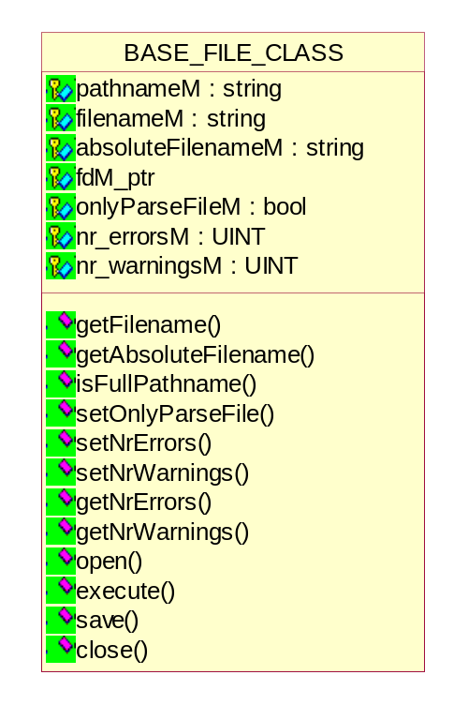
Figure 5 Class diagram of Base File

Return the filename
const char *getFilename();
This function will return the filename associated to this instance of the class.

Return the filename
const char *getFilename();
This function will return the filename associated to this instance of the class.

Check for full pathname
bool isFullPathname();
This function returns true if the filename associated to this instance of the class contains an absolute path to the file. It returns false if the path is relative.

Set flag for parsing file only
void setOnlyParseFile(bool onlyParseFile);
This function sets a flag, if passed true to the function, which indicates that the file associated to this instance of the class will only be parsed and not executed. If false is passed to the function, the file will also be executed. This depends on the type of the file and needs to be handled by the deriving class.

Setting/Getting the number of errors/warnings
void setNrErrors(UINT nr);
void setNrWarnings(UINT nr);
UINT getNrErrors();
UINT getNrWarnings();
This function sets/gets the number of errors/warnings found in the file.

Open the file
virtual bool open(bool forReading = true);
This function opens the file associated with the instance of the class. A flag passed to this function indicates if the file is to be opened for read access (pass true) or for write access (pass false). The function will return true if the file has been successfully opened and false otherwise.

Execute the file
virtual bool execute() = 0;
This function is just defined in this class. The exact implementation – if applicable – needs to be done in the deriving class.

Save the file
virtual bool save();
This function returns true if the file has been successfully stored and false otherwise. Since this function is located in a base class, it has no knowledge of what data to store and therefore it always returns false. Any deriving class needs to implement the correct functionality.

Close the file
virtual void close();
This function is the counterpart of open. It does nothing more than closing an open file.

Endian class
Data transfer happens in certain transfer syntax. The most obvious transfer syntax within DICOM is the distinction between big endian and little endian. One aspect of a DICOM Transfer Syntax is the byte ordering or “endian-ness” that should be used when importing/exporting parameter/attribute values. An abstract base ENDIAN_CLASS will be used to handle all byte swapping. This ENDIAN_CLASS will provide import/export operators for all Value Representations (data types) affected by byte order (AT, FD, FL, SS. US, SL, UL, OF, OW).
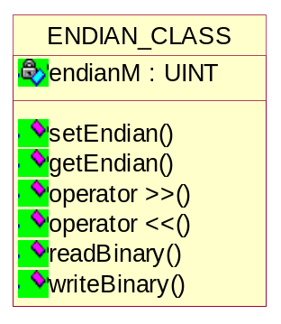
Figure 6 Class diagram of Endian

The import/export operators (>> and <<) will call virtual readBinary( ) and writeBinary( ) methods respectively. Classes derived from the ENDIAN_CLASS will implement the readBinary( ) and writeBinary( ) methods in a manner suitable to the type of read and write operation. The order in which bytes, of the value being read/written, is defined by the setEndian( ) method – LittleEndian or BigEndian.

Set endianess
void setEndian(UINT endian);
This function takes a parameter, which sets the endianess for the transfer syntax. The possible values for the parameter are LITTLE_ENDIAN and BIG_ENDIAN.

Get endianess
inline UINT getEndian();
This function returns the endianess of the current transfer syntax.

Read binary data
virtual INT readBinary(BYTE*, UINT) = 0;
The operator >> (see 4.2.5) uses the function readBinary() to actually read data from a data stream. This function is not implemented in the ENDIAN_CLASS, but needs to be implemented in any class deriving from ENDIAN_CLASS. The reason is that ENDIAN_CLASS does not know where to retrieve the data.

Write binary data
virtual bool writeBinary(const BYTE*, UINT) = 0;
The operator << (see 4.2.6) uses the function writeBinary() to actually write data to a data stream. This function is not implemented in the ENDIAN_CLASS, but needs to be implemented in any class deriving from ENDIAN_CLASS. The reason is that ENDIAN_CLASS does not know where to store the data.

>> operator
bool operator >> (BYTE&);
bool operator >> (UINT16&);
bool operator >> (UINT32&);
bool operator >> (float&);
bool operator >> (double&);
inline bool operator >> (char& x);
inline bool operator >> (INT16& x);
inline bool operator >> (INT32& x);
Multiple variants of the >> operator are implemented for reading data from a stream. Each of those operators reads the amount of bytes from the input stream and, if needed, swaps bytes to represent the endianess of the system.

<< operator
bool operator << (BYTE&);
bool operator << (UINT16&);
bool operator << (UINT32&);
bool operator << (float&);
bool operator << (double&);
inline bool operator << (char& x);
inline bool operator << (INT16& x);
inline bool operator << (INT32& x);
Multiple variants of the << operator are implemented for writing data to a stream. If needed, the bytes are swapped from the endianess of the system to the requested endianess. The resulting bytes are then written to the output stream.

Data transfer class
The DATA_TF_CLASS will be an abstract class that is derived from the ENDIAN_CLASS and will be used by the DICOM Object import/export methods.
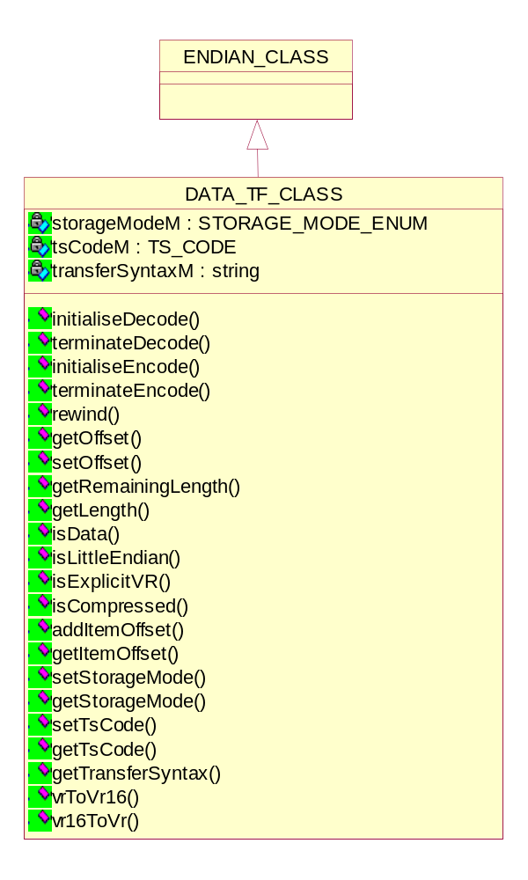
Figure 7 Class diagram of Data Transfer

Pure virtual functions
The following methods are pure virtual and implemented by the derived classes.
virtual bool initialiseDecode(bool) = 0;
virtual bool terminateDecode() = 0;
virtual bool initialiseEncode() = 0;
virtual bool terminateEncode() = 0;
virtual bool rewind(UINT) = 0;
virtual UINT getOffset() = 0;
virtual bool setOffset(UINT) = 0;
virtual UINT getRemainingLength() = 0;

Checking for little endianess of current data transfer
bool isLittleEndian();
The function returns true if the current data transfer is in little endian, otherwise it returns false.

Determine if VR is explicit
bool isExplicitVR();
The function returns true if the current data transfer defines explicit VR representation, otherwise it returns false.

Determine if data is compressed
bool isCompressed();
The function returns true if the current data transfer uses any form of compression, otherwise it returns false.

Getting/Setting the storage mode
void setStorageMode(STORAGE_MODE_ENUM storageMode);
STORAGE_MODE_ENUM getStorageMode();

Getting/Setting the transfer syntax code
void setTsCode(TS_CODE, string);
TS_CODE getTsCode();

Getting the transfer syntax
char *getTransferSyntax();

Mapping of the VR into a UINT presentation
UINT16 vrToVr16(ATTR_VR_ENUM);
This method is used to map the enumerated VR value into a UINT16 presentation suitable for encoding.

Mapping of the VR into a enumerated VR value presentation
ATTR_VR_ENUM vr16ToVr(UINT16);
This method is used to map UINT16 VR value into a enumerated VR value presentation.

File transfer class
The FILE_TF_CLASS, also derived from the DATA_TF_CLASS, will implement readBinary( ) and writeBinary( ) methods for file data transfer (i.e.DICOM Object import/export from/to file).
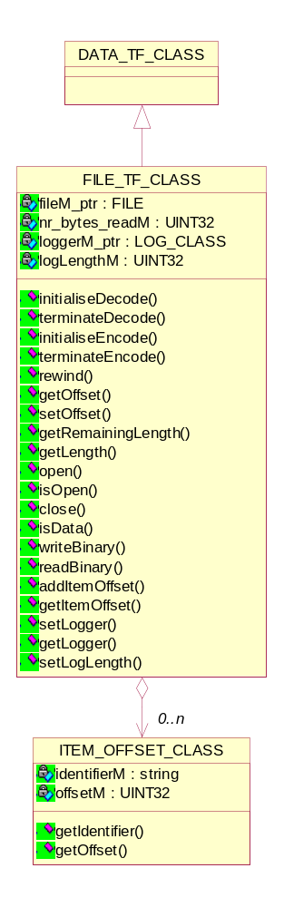
Figure 8 Class Diagram of File Transfer

Initializing the data decode
bool initialiseDecode(bool);
The function provides default implementation and always returns true.

Terminating the data decode
bool terminateDecode();
The function provides default implementation and always returns true.

Initializing the data encode
bool initialiseEncode();
The function provides default implementation and always returns true.

Terminating the data encode
bool terminateEncode();
The function provides default implementation and always returns true.

Rewinding the file offset by the given length
bool rewind(UINT);

Getting/setting the current file offset
UINT getOffset();
bool setOffset(UINT);

Checking for the remaining data
bool isData();

Opening the file for data transfer
bool open(string, string);
This method is used to open the file for data transfer in the given mode.

Closing the file after data transfer
void close();

Getting the current file length
UINT getLength();

Computing the remaining data length
UINT getRemainingLength();

Writing the given data to the file
bool writeBinary(const BYTE *, UINT);
The function returns true if the writing operation is successful, otherwise it returns false.

Reading the data from the file
INT readBinary(BYTE *, UINT);
The function returns the no. of bytes read.

Adding/getting the item offsets
void addItemOffset(string identifier, UINT32 offset);
UINT32 getItemOffset(string);

Setting/Getting the logger
void setLogger(LOG_CLASS *logger_ptr);
LOG_CLASS *getLogger();

Helper functions
The utility component provides many functions to other libraries of DVT.

Memory functions

Copying the byte
void byteCopy(BYTE *destination_ptr, BYTE *source_ptr, UINT32 length);
This function copies the contents of a buffer with offset source_ptr to destination_ptr. The number of bytes to copy is specified by length. The memory for the destination buffer needs to be allocated by the caller. No checks are made if enough memory is allocated and if source_ptr points to a valid buffer.

Comparing the byte
bool byteCompare(BYTE *buffer1_ptr, BYTE *buffer2_ptr, UINT32 length);
This function compares the content of two buffers. The number of bytes to compare is specified by length. If both buffers are equal in content, the function returns true, otherwise it returns false. No checks are made if buffer1_ptr and buffer2_ptr are pointing to valid buffers.

Clearing the byte content in a buffer
void byteZero(BYTE *buffer_ptr, UINT32 length);
This function cleans the content of the given buffer. The size of the buffer to clean is specified by length. The memory of the buffer needs to be allocated by the caller. No checks are made if the argument buffer_ptr is pointing to a valid buffer.

Filling the byte content in a buffer
void byteFill(BYTE *buffer_ptr, BYTE value, UINT32 length);
This function fills the given buffer with the value specified by value. The size of the buffer is specified by length. The memory of the buffer needs to be allocated by the caller. No checks are made if the argument buffer_ptr is pointing to a valid buffer.

Filling the byte pattern in a buffer
void bytePattern(BYTE *buffer_ptr, UINT32 length);
This function fills the buffer specified by buffer_ptr with a pattern. The size of the buffer is specified by length. The memory of the buffer needs to be allocated by the caller. No checks are made if the argument buffer_ptr is pointing to a valid buffer.
The pattern written to the buffer is abcdefghijklmnopqrstuvwxyz with a <cr><lf>.

Getting the size of a buffer
UINT byteStrLen(BYTE *buffer_ptr);
This function returns the size of the buffer specified by buffer_ptr. The first occurrence of a NULL character is the size delimiter. No checks are made if the argument buffer_ptr is pointing to a valid buffer.

Index handling functions

Resetting the counter
void resetUniq8odd(void);
This function resets a global counter for odd numbers to 0.

Getting the odd number
BYTE uniq8odd(void);
This function returns an odd number ranging from 0 to 255. This number is always 2 higher than the previous one returned. The exception to this rule is that the value will wrap back to 0 when 255 was the last value returned.

DVT output file handling functions

Returning the next Storage File Extension index
int getNextSfeIndex(string storageRoot, STORAGE_FILE_EXTENSION_ENUM extension);
Each directory where a results file is stored by DVT contains an index file. The filename is specified by the global definition STORAGE_FILE_INDEX_NAME. The location of where the file will be stored by DVT is passed by the variable storageRoot. The extension passed by extension can be one of the following: SFE_DOT_DCM, SFE_DOT_RAW, SFE_DOT_PIX or SFE_DOT_RES. The function returns the next available index for the specified file type.

Returning the next pixel index
Int getPixIndex(string storageRoot);
This function will return the next available index for a pixel file. See the description of getNextSfeIndex for the meaning of the variable storageRoot.

Returning the next result file index
Int getResIndex(string storageRoot);
This function will return the next available index for a result file. See the description of getNextSfeIndex for the meaning of the variable storageRoot.

Getting the Storage File name
void getStorageFilename(string storageRoot,
int sessionId,
string &storageFilename,
STORAGE_FILE_EXTENSION_ENUM extension);
This function generates a filename based on a session identifier specified by sessionId and an index. The index generation is done by the getNextSfeIndex function. The extension of the file is specified by extension which can be one of the following: SFE_DOT_DCM, SFE_DOT_RAW, SFE_DOT_PIX or SFE_DOT_RES. The physical location of the file needs to be passed in storageRoot This can be an absolute path or a relative path. The generated filename will be returned in storageFilename.

DICOM specific helper functions

Mapping the command name
Char* mapCommandName(DIMSE_CMD_ENUM commanded);
This function returns the given command as a string. The following values are possible for passing to commandId: DIMSE_CMD_CECHO_RQ, DIMSE_CMD_CECHO_RSP,
DIMSE_CMD_CFIND_RQ, DIMSE_CMD_CFIND_RSP, DIMSE_CMD_CGET_RQ, DIMSE_CMD_CGET_RSP, DIMSE_CMD_CMOVE_RQ, DIMSE_CMD_CMOVE_RSP,
DIMSE_CMD_CSTORE_RQ, DIMSE_CMD_CSTORE_RSP, DIMSE_CMD_CCANCEL_RQ, DIMSE_CMD_NACTION_RQ, DIMSE_CMD_NACTION_RSP, DIMSE_CMD_NCREATE_RQ, DIMSE_CMD_NCREATE_RSP, DIMSE_CMD_NDELETE_RQ, DIMSE_CMD_NDELETE_RSP,
DIMSE_CMD_NEVENTREPORT_RQ, DIMSE_CMD_NEVENTREPORT_RSP, DIMSE_CMD_NGET_RQ, DIMSE_CMD_NGET_RSP, DIMSE_CMD_NSET_RQ, DIMSE_CMD_NSET_RSP.

Mapping the attribute type
char* mapTypeName(ATTR_TYPE_ENUM type);
This function returns the given type as a string. The following values are possible for passing to type: ATTR_TYPE_1, ATTR_TYPE_1C, ATTR_TYPE_2, ATTR_TYPE_2C, ATTR_TYPE_3, ATTR_TYPE_3C.

Mapping the value type
Char* mapValueTypeName(ATTR_VAL_TYPE_ENUM type);
This function returns the given value type as a string. The following values are possible for passing to type: ATTR_VAL_TYPE_ENUMERATED, ATTR_VAL_TYPE_DEFINED or ATTR_VAL_TYPE_NOVALUE.

Mapping the command ID
UINT16 mapCommandId(DIMSE_CMD_ENUM commandId);
This function maps the given value to a command field and returns it.

Mapping the command field
DIMSE_CMD_ENUM mapCommandField(UINT16 commandField);
This function maps the given value to a command identifier and returns it.

Checking the validity of UID
bool isUID(const char *uid_ptr);
This function checks if a given UID is valid. When valid, the function returns true, otherwise it returns false.

Creating the UID
void createUID(char *uid_ptr, char *uidRoot_ptr);
This function creates a new UID by appending the current time to a given UID root. The caller has to allocate enough memory for creating the new UID and pass it to uid_ptr. No checks are made if uid_ptr and uidRoot_ptr are pointing to a correct memory location.

Date and time functions

Getting the current year and day
void dayOfYear(int *year, int *day);
This function will return the current year and the current day of the year.

Getting the current month and day
void monthDay(int year, int yearDay, int *pMonth, int *pDay);
This function returns the month and the day of the month. These values are based on the year value and the day number of the year passed in yearDay. No checks are made if year and yearDay are valid values.

Getting the current date
void replaceDate(char *dateString_ptr,
int replacePosition,
int replaceLength,
int dayOffset);
This function replaces 8 characters in the given dateString_ptr argument with the current date added with dayOffset. The position at which the date will be written is specified by replacePosition. The number of characters to be appended after the new date needs to be specified by replaceLength. No checks are made if dateString_ptr is pointing to a valid memory location.

Getting the real date
UINT mapDate(char *dateString_ptr);
If a given string contains a predefined date value, it is replaced by a real date in the format yyyymmdd. The predefined values are YESTERDAY, TODAY and TOMORROW.

Getting the current time
void replaceTime (char *timeString_ptr, int replacePosition, int replaceLength);
This function replaces 6 characters in the given timeString_ptr argument with the current time. The position at which the time will be written is specified by replacePosition. The number of characters to be appended after the new time needs to be specified by replaceLength. No checks are made if timeString_ptr is pointing to a valid memory location.

Getting the real time
UINT mapTime (char*);
If a given string contains a predefined time value, it is replaced by a real time in the format hhmmss. The only predefined value is TIMENOW.

Getting the time as defined in system
char* timeStamp (void);
This function returns the current time represented in the locale defined on the system.

String functions

Comparing the strings
bool stringValuesEqual (const BYTE *refValue, const BYTE *srcValue,
int maxLength,
bool leadingSpace, bool trailingSpace);
This function compares refValue with srcValue. A maximum of maxLength characters or the length of the shortest string is compared whichever the shortest. If leadingSpace is false, a leading space character is not significant for comparison. If trailingSpace is false, a trailing space character is not significant for comparison. If one or both flags are set to true, the respective space character is significant for comparison.

Stripping the leading/trailing spaces in a string
int stringStrip (const BYTE *string,
int maxLength,
bool leadingSpace, bool trailingSpace,
const BYTE **stringP);
This function strips a leading space or a trailing space from a given string passed in string. If leadingSpace or trailingSpace is false, the corresponding space character, if present in the string, will be stripped. The function will return a pointer to the first significant character in stringP. The length of the string will be returned as a return value.

Decoding the escape sequence
bool decodeEscSeq (BYTE *escSeq_ptr, UINT maxSize, UINT &seqLength, bool &gr, bool &multibyte);

Converting the hex
char* convertHex (char* string);

Getting the epsilon
double getEpsilon (char ds[]);

Filename functions

Checking for the path in the filename
bool containsPath (string filename);
This function returns true if the filename passed to this function contains a path to the filename, otherwise it returns false.

Checking for the absolute path
bool isAbsolutePath (string filename);
This function returns true if the filename passed to this function contains an absolute path to the filename, otherwise it returns false.

Checking for the relative path
bool isRelativePath (string filename);
This function returns true if the filename passed to this function contains a relative path to the filename, otherwise it returns false.

Reducing the pathname
void reducePathname (char*);

Stripping the pathname
string stripPath (string fullname);
This function strips the path, if applicable, from the file and returns the filename. No checks are made if fullname is pointing to a valid memory location.

Correcting the pathname for a particular OS
string correctPathnameForOS (string pathname);
This function corrects the given pathname to the format used by the operating system. On Windows systems, a path uses backslashes (\). On UNIX systems, a path uses slashes (/).

Getting the current working directory
string getCurrentWorkingDirectory (void);
This function returns the current working directory.

Creating the directory
bool createDirectory (string fullname);
This function creates the directory passed in fullname. Any non-existent path will be created by this function.

Checking for the file extension
bool isFileExtension (string filename, char *extension_ptr);
This function checks if the given filename has the extension passed by extension_ptr. There are no checks made on the validity of the extension passed to this function.

Detail Design of logging component

Log Class
The Logging component will provide a mechanism to allow all kinds of status and result information to be logged. The other components will make calls to methods provided by the abstract base LOG_CLASS.

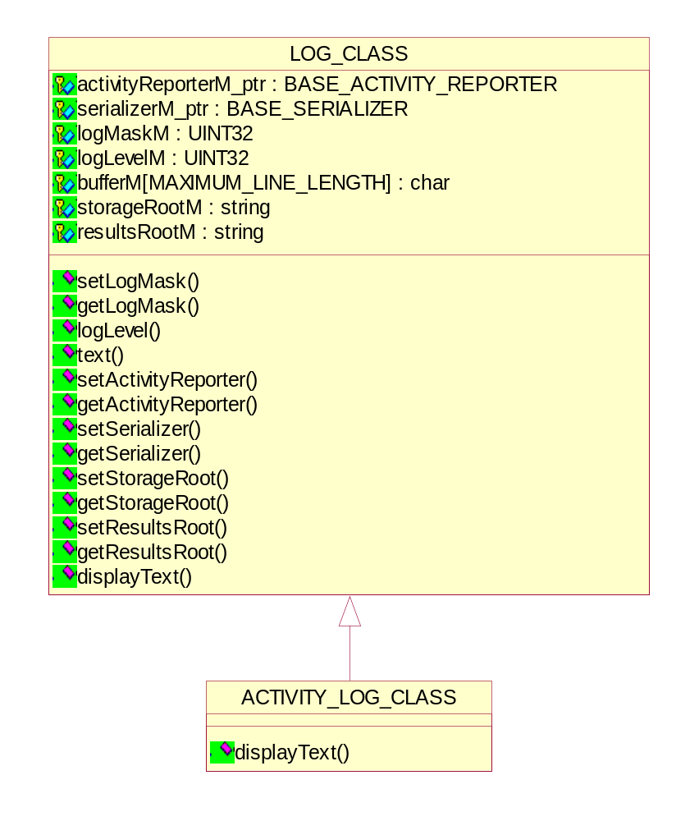
Figure 9 Class diagram of Log

Setting/Getting the log mask
void setLogMask(UINT32);
UINT32 getLogMask();

Logging the text
void text(BYTE, char*, ...);
void text(UINT32, BYTE, char*, ...);

Setting the log level
UINT32 logLevel(UINT32);

Setting/Getting the activity reporter
void setActivityReporter(BASE_ACTIVITY_REPORTER*);
BASE_ACTIVITY_REPORTER* getActivityReporter();

Setting/Getting the serializer
void setSerializer(BASE_SERIALIZER*);
BASE_SERIALIZER* getSerializer();

Setting/Getting the storage root directory
void setStorageRoot(string);
const char *getStorageRoot();

Setting/Getting the result root directory
void setResultsRoot(string);
const char *getResultsRoot();

Displaying the text in the UI
virtual void displayText() = 0;

Log Message Class
This class is used for storing all messages of a specific object (can be attribute, item, global messages etc).

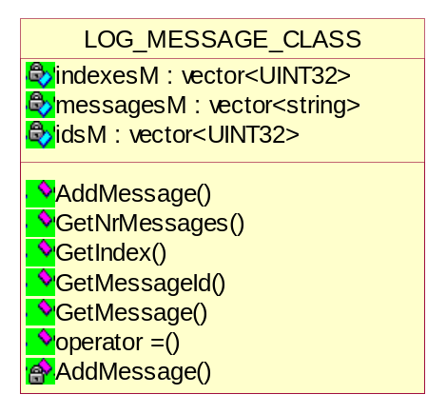
Figure 10 Class diagram of Log message

Adding the message to the message list
void AddMessage(UINT32 id, string message);
void AddMessage(UINT32 index, UINT32 id, string message);

Getting the number of messages from the message list
int GetNrMessages(void);

Getting the message ID by index
UINT32 GetMessageId(int i);

Getting the message index
UINT32 GetIndex(int i);

Getting the message by index
string GetMessage(int i);

Base Confirmer Class
The Base Confirmer is the abstract class and derived classes should implement the defined methods. This class is used for user interaction.

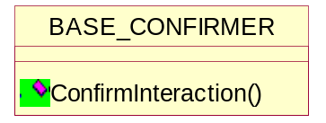
Figure 11 Class diagram of Base Confirmer

Confirming the interaction
virtual void ConfirmInteraction() = 0;

Base Activity Reporter Class
The Base Activity Reporter is the abstract class and derived classes should implement the defined methods. This class is used for reporting all activities to UI for user interpretation.

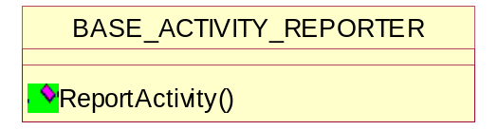
Figure 12 Class diagram of Base Activity Reporter

Reporting the activities to UI based on report level
virtual void ReportActivity(ReportLevel level, const char* message) = 0;

Base Serializer Class
The Base Serializer is the abstract class and derived classes should implement the defined methods. This class is used for serializing all results to XML files. DVT stores the results of each test (either by DICOMScript, DICOMSuperScript, VBScript, Media Validation or Emulation) in a _RES.xml file.
Two types of results files can be generated:
- Detailed Results File – the full validation results are stored in the detailed results file.
- Summary Results File – a summary of the validation results, showing ERROR’s and WARNING’s, are stored in the summary results file.

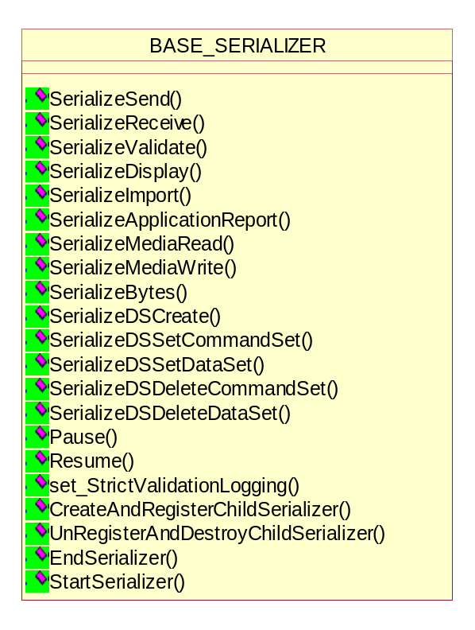
Figure 13 Class diagram of Base Serializer
The following methods are pure virtual and derived classes should provide implementation of these methods.

Specific serialization methods for ACSE & DIMSE objects
virtual void SerializeSend(DCM_COMMAND_CLASS*, DCM_DATASET_CLASS*) = 0;
virtual void SerializeSend(ABORT_RQ_CLASS*) = 0;
virtual void SerializeSend(ASSOCIATE_AC_CLASS*) = 0;
virtual void SerializeSend(ASSOCIATE_RJ_CLASS*) = 0;
virtual void SerializeSend(ASSOCIATE_RQ_CLASS*) = 0;
virtual void SerializeSend(RELEASE_RP_CLASS*) = 0;
virtual void SerializeSend(RELEASE_RQ_CLASS*) = 0;
virtual void SerializeReceive(DCM_COMMAND_CLASS*, DCM_DATASET_CLASS*) = 0;
virtual void SerializeReceive(ABORT_RQ_CLASS*) = 0;
virtual void SerializeReceive(ASSOCIATE_AC_CLASS*) = 0;
virtual void SerializeReceive(ASSOCIATE_RJ_CLASS*) = 0;
virtual void SerializeReceive(ASSOCIATE_RQ_CLASS*) = 0;
virtual void SerializeReceive(RELEASE_RP_CLASS*) = 0;
virtual void SerializeReceive(RELEASE_RQ_CLASS*) = 0;
virtual void SerializeValidate(VAL_OBJECT_RESULTS_CLASS*, UINT) = 0;
virtual void SerializeValidate(VAL_OBJECT_RESULTS_CLASS*, RECORD_LINK_VECTOR*, UINT) = 0;
virtual void SerializeValidate(ABORT_RQ_VALIDATOR_CLASS*) = 0;
virtual void SerializeValidate(ASSOCIATE_AC_VALIDATOR_CLASS*) = 0;
virtual void SerializeValidate(ASSOCIATE_RJ_VALIDATOR_CLASS*) = 0;
virtual void SerializeValidate(ASSOCIATE_RQ_VALIDATOR_CLASS*) = 0;
virtual void SerializeValidate(RELEASE_RP_VALIDATOR_CLASS*) = 0;
virtual void SerializeValidate(RELEASE_RQ_VALIDATOR_CLASS*) = 0;
virtual void SerializeValidate(RECORD_RESULTS_CLASS*, UINT) = 0;
virtual void SerializeDisplay(DCM_ATTRIBUTE_CLASS*) = 0;
virtual void SerializeDisplay(DCM_COMMAND_CLASS*,DCM_DATASET_CLASS*)= 0;
virtual void SerializeDisplay(DCM_DATASET_CLASS*) = 0;
virtual void SerializeDisplay(FILE_DATASET_CLASS*) = 0;
virtual void SerializeImport(DCM_COMMAND_CLASS*, DCM_DATASET_CLASS*) = 0;
virtual void SerializeApplicationReport(ReportLevel reportLevel, const char* message) = 0;
virtual void SerializeMediaRead(const char* fileName, FILE_DATASET_CLASS*) = 0;
virtual void SerializeMediaWrite(const char* fileName, FILE_DATASET_CLASS*) = 0;
virtual void SerializeBytes(BYTE* bytes, int length, const char* pDescription) = 0;

Specific serialization methods for old style CREATE, SET, DELETE DicomScript commands
virtual void SerializeDSCreate(const char* commandSetRefId, DCM_COMMAND_CLASS*) = 0;
virtual void SerializeDSCreate(const char* commandSetRefId,
DCM_COMMAND_CLASS*,
const char* dataSetRefId,
DCM_DATASET_CLASS*) = 0;
virtual void SerializeDSSetCommandSet(const char* commandSetRefId, DCM_COMMAND_CLASS*) = 0;
virtual void SerializeDSSetDataSet(const char* dataSetRefId, DCM_DATASET_CLASS*) = 0;
virtual void SerializeDSDeleteCommandSet(const char* commandSetRefId, DCM_COMMAND_CLASS*) = 0;
virtual void SerializeDSDeleteDataSet(const char* dataSetRefId, DCM_DATASET_CLASS*) = 0;
virtual void Pause(void) = 0;
virtual void Resume(void) = 0;
virtual void set_StrictValidationLogging(bool) = 0;
virtual BASE_SERIALIZER* CreateAndRegisterChildSerializer( SerializerNodeType reasonForChildSerializer) = 0;
virtual void UnRegisterAndDestroyChildSerializer(BASE_SERIALIZER* child_ptr) = 0;
virtual void EndSerializer() = 0;
virtual void StartSerializer() = 0;

